EMI Online Courses
Video Production Workflow
- Pre-Production: The planning stage. At this stage, the meeting is a pressing matter.
Please arrange a meeting with EMI DA, so we will help you best prepare to shoot your video. (with the MEETING CHECKLIST)
- Production: Shooting your video. This stage will include the setting of the camera, lighting, and audio equipment to best execute your vision.
- Post-Production: Editing your video. This stage will cover the video edition, and manage how to put all the final pieces together to present a high-quality video production.

The following is the EMI Online Course Shooting Workflow Diagram.
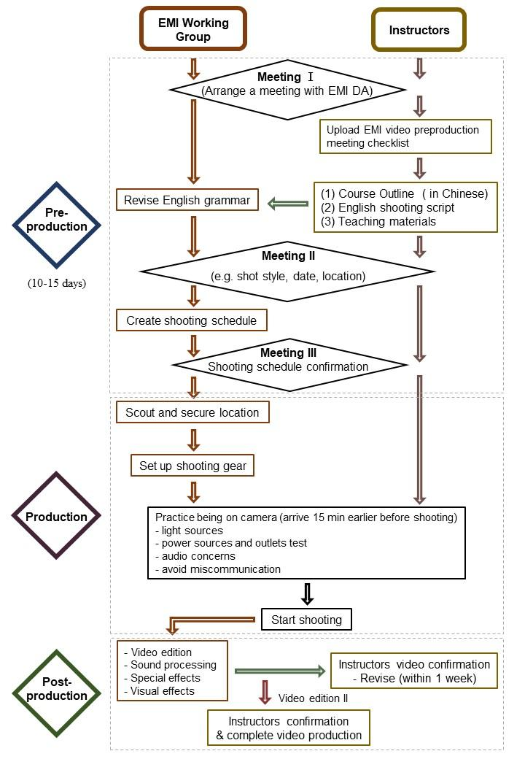

*Contact us:
EMI Digital Assistant ( DA )
Pei Yun-Wu ( Amanda ) Email： r101124@gap.kmu.edu.tw ext. 2137 #85
Yang Pu Xuan ( Zoey ) Email：r101123@gap.kmu.edu.tw ext.2137 #36

