壁報論文格式範例

Presentation Title In Bold And Capitalize The First Letter Of Each Word And No Full Stop At End
Yin-Chun Tien^{1,2}, Eing-Mei Tsai¹. ¹Institute or Dept Name, Organization; ²Institute or Dept Name, Organization.

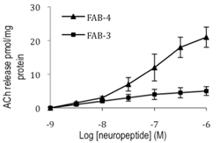
Background. Text to begin immediately following the heading and without additional line spacing.
Aim. Text to begin immediately following the heading and without additional line spacing.
Methods. Text to begin immediately following the heading and without additional line spacing.
Results. Text to begin immediately following the heading and without additional line spacing.
Discussion. Text to begin immediately following the heading and without additional line spacing. Do not alter the structure of this document as this document will be automatically processed. Do not change the margins, the font, size or any other setup on this template. The abstract should be left-and right-justified. The abstract must fit on this one page in the preset margins. Line spacing must be single. The abstract must be typed in Arial 11 point. Do not use bold in the abstract text, only the title should be in bold. Abstract pages will be printed in black and white only, therefore it is preferred that all tables and images are greyscale. Please pay particular attention to these instructions as abstracts that do not conform will not be accepted.

P.S: Discussion and/or Conclusion are all acceptable.

